September 28. 20165
Huntersville Ocular Melanoma Cluster Report:
On 9/25/2015 Dave Stetzer and I visited Huntersville NC to study environmental exposures to high frequency electric currents in the Hopewell High school area , since a cluster of ocular melanoma (OM) had been reported in students.
Background: In fall 2014, I received a phone call from Tom Kelly, residing in Kona HI. His wife had ocular melanoma, and he alerted me to a cluster of ocular melanoma in Hopewell High School in Huntersville NC, and to a channel 9 TV report of the cluster by Jim Bradley. He also gave me a contact E-mail and phone for Melody Kling, President of A Cure In Sight , an ocular melanoma support group. She gave me contact information and I contacted and interviewed some of the cases and surviving parents.
A Google Earth photo of the school revealed it was adjacent to a Piedmont liquid natural gas (LNG) compressor and storage station on a 24 inch natural gas pipeline.
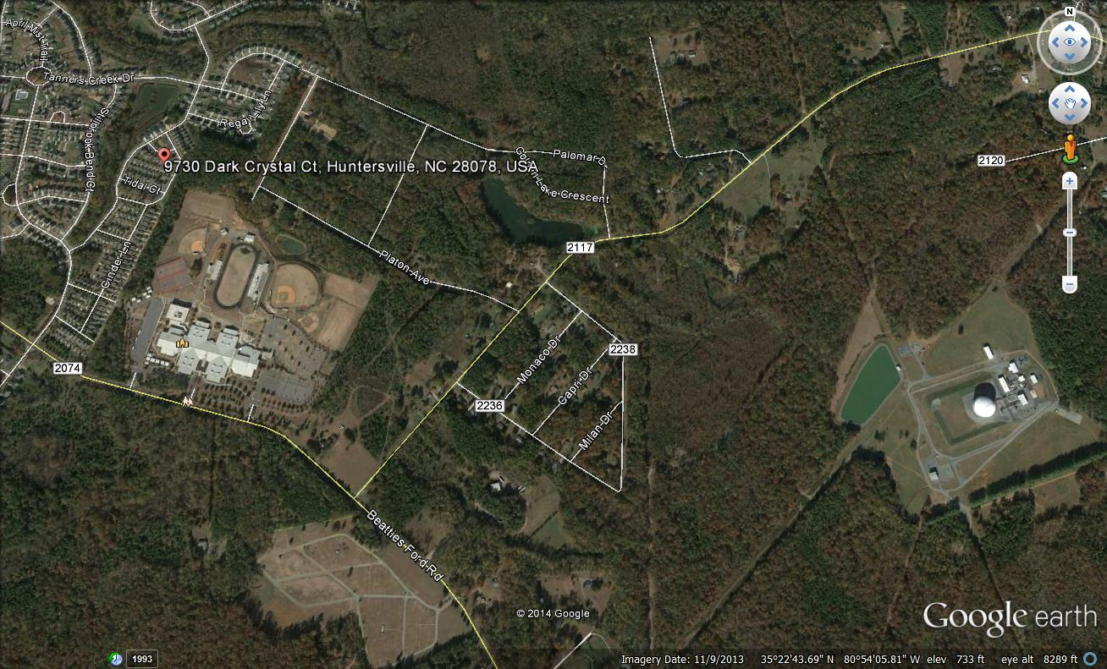
The school is shown in the yellow circle and the LNG plant in the red circle. The red dot above the school was the residence of a case of ocular melanoma who never attended the school. The school was built in 2001. the LNG plant was already there.
I suspected that electrical pollution from the LNG plant might have caused the cluster. I called the plant and learned that they had variable frequency drives (VFDs) on their 300 horse power electric motors. Dave and I both had experience with animals and people becoming ill after exposure to small horsepower VFDs. Many dairy cows have died from exposures to fields generated by VFDs less than 10 HP.
I contacted Ann Clark, then Deputy Superintendent of the of the Charlotte Mecklenburg school district in November 2014 . The following are the Emails I sent her and the ultimate refusal I received from the school district attorney:
From: Sam Milham [smilham2@comcast.net]
Sent: Sunday, November 16, 2014 8:14 PM
To: 'a.clark@cms.k12.nc.us'
Cc: 'Dave Stetzer'
Subject: ocular melanoma (OM ) cluster
Attachments: La Quinta Middle school teachers' cancers.pdf

Dear Deputy Superintendant Clark,

I'm a semi-retired physician/epidemiologist, and have studied and reported on a number of cancer clusters. I have studied the health effects of electromagnetic fields for nearly 30 years. I have published about 100 scientific papers and have written a book called Dirty Electricity. My website has a copy of my CV and a number of recent papers. Http://www.sammilham.com

I learned about the Hopewell high school ocular melanoma (OM) cluster a couple of months ago when man from Kona, Hawaii, whose wife has OM, sent me the video link from Channel 9 Charlotte describing the cluster. He put me in touch with two 501 C3 foundations which focus on OM, A Cure Insight, and the Ocular Melanoma Foundation (OMF). Melody Burchett Kling had OM, is in Raleigh NC and is my contact to A Cure Insight. She gave me contact information for the Huntersville cluster cases.

The 5 cases of OM in the cluster are all female; 3 former students at Hopewell High school and 2 women who lived near the school. What is really striking about them is how young they are. OM has an incidence of 6 per million with an average age of 55 and a slight male excess. Two of the students died at ages 27 and 28, and the one student survivor is age 19, The two non- student cases are ages 29 and 31.

I looked up the Hopewell high school white student population (1718 students x 46% white = 790). OM is rarely seen in non-whites. Since the school has been open for 13 years, the population at risk is 790 x 13 = 10,270. Multiplying this by the OM incidence gives 10,270 x 6/1,000,000 = 0.06 cases expected. Since 3 cases occurred, the relative risk of OM in the school is 3/0.06 or 50. That is, the 3 OM cases in the school student population was 50 times expected. Since the incidence of OM in high school aged children is much lower than 6 per million, the true risk is at least 100 times expected. The 2 community cases means that the etiologic agent is not limited to the school.

I'd like your help in getting access to the school for a couple of hours in mid- December 2014. Measuring the electrical pollution in the school and in the neighborhood should be able to identify its source. In two other schools I've studied, the source of the problem was of non-school origin (a cell tower on campus at one school, and a defective utility substation in another). Once identified, it may be possible to eliminate the source.

I'm attaching a study of a cancer cluster in middle school teachers caused by electrical pollution in their classrooms. Sadly, former students at that school in their early twenties are now showing up with thyroid cancer after three years of exposure. All the cancer clusters I've examined have a connection to electrical pollution.

My colleague and mentor Dave Stetzer from Wisconsin will help me in the investigation. I'm at my winter home in the California desert. We will cover the costs of the investigation.

My phone in Indio CA is (760) 775-5878.

Respectfully, Sam Milham MD

Sam Milham <sam.milham@gmail.com> | Sep 22 (6 days ago)
to Ann, matthew.hayes, Andre, John, Dave

Dear CMS people,

Dave Stetzer and I will be in Huntersville to study the ocular melanoma cluster this Friday and Saturday Sept. 25-26. It is very important that we get into the school to make electrical measurements.

We are quite certain that the epidemic was caused by bad electricity from the liquid natural gas plant near the school. They have variable speed drives on their 300 horsepower motors which cause problems with electrical equipment and human health.

If this ever comes to litigation, the responsible parties are the manufacturer of the variable speed drives and the electric utility which violates its own and federal rules by dumping dirty electricity into the ground for return to the substation.

The only role the school played in the epidemic was providing a large, susceptible exposed population.

We await your decision, so we can plan our visit.

Best, Sam MIlham MD
Andre F. Mayes | Sep 22 (6 days ago)
to me, Ann, MATTHEW, John

Dr. Milham, I am one of the CMS attorneys and have been asked to respond to your communications to me and other CMS employees regarding your request to enter Hopewell High School to take electrical measurements.

The Mecklenburg County Health Department-Epidemiology staff, the North Carolina Department of Health & Human Services – Environmental Epidemiology branch, the North Carolina Central Cancer Registry, and the North Carolina Department of Environment and Natural Resources were consulted as part of a comprehensive analysis of Hopewell High School and its surrounding environment (soil, water , school construction, asbestos, electromagnetic exposure) within a 2 mile radius of the school and determined that the school was in compliance with the environmental standards required by Mecklenburg County and North Carolina. These state and county regulatory agencies concluded thatfurther testing of electromagnetic fields was not warranted. CMS will continue to rely on the expertise and recommendations of these regulatory agencies for guidance. Accordingly, you will not be permitted to take electrical measurements at Hopewell High School at this time.

If the regulatory agencies ever revise their recommendation regarding electromagnetic testing , CMS will be happy to reconsider your request at that time.

André F. Mayes
Deputy General Counsel
Charlotte-Mecklenburg Schools
980.343.5901 (phone)|980.343.5739 (fax)

I phoned the LNG plant and talked to Gary Northrup, plant manager, the week of September 15, 2015 to request admission to the plant. He referred me to Matt Kanes, Director of Safety and Communications for Piedmont. I talked to him also, making the same request, and was told that he would contact me with a decision by Sunday September 20 when I was scheduled to begin a trip to visit Dave Stetzer in Blair WI, to travel together to Huntersville on September 24. He never contacted me or responded to numerous telephone messages. No E-mail addresses were available for either of them.
Huntersville electricity is provided by ElectriCities. ElectriCities is a membership organization including public power communities in North Carolina, South Carolina and Virginia. ElectriCities also provides management services to the state's two municipal power agencies - North Carolina Municipal Power Agency Number 1 and North Carolina Eastern Municipal Power Agency.
In the US, electricity is distributed in a grounded Wye system with a wire connecting the neutral center tap of the transformer to the earth. All the electricity delivered has to return to the substation it came from and when the grid was built, most of it returned on the utility primary neutral wire. Most loads like incandescent lights and electric motors were linear loads, in that they did nothing to change the 60 Hz current powering them. With the development of computers , inverters, variable frequency motor drives, compact fluorescent lights and other non linear loads, the 60 Hz waveforms were deformed by the high frequencies which were added to the neutral return currents. High frequencies don't travel well on the neutral return wires, requiring a larger diameter wire to carry higher frequencies than 60 Hz. The inadequate neutrals heated up and caused building fires. Building codes were changed to require more robust in-building neutral return wires, but the utilities instead of adding increase neutral capacity to their wire neutrals, simply used the down grounds at the transformers to dump the return currents into the earth for substation return. By 1998, about 70 % of all electricity delivered, returned to the substation via the earth. Europe has a delta distribution system with all the delivered electricity returning to the substation via wires. The US National Electric Safety Code and most state public utility commissions have rules forbidding use of the earth as a primary neutral return.
The original electric motors had simple on /off switches or may have had switches for high, medium and low speeds. The development of variable frequency drives (VFDs) allowed motor speed to be infinitely varied. Variable frequency drives generate electrical pollution which adversely affects electric equipment. VFDs on small, low horsepower motors drastically reduces milk production in dairy cattle and has caused serious illness in humans. The Piedmont LNG plant has VFDs on 300 horsepower motors.
Method: On September 25, 2015, Dave Stetzer and I were accompanied by Joe Wagner, an ocular melanoma case who formerly worked as a cable installer in the Beatties Ford Road area. We drove around the school and LNG plant area with an AM radio tuned off station listening for static patterns, and covered the Beatties Ford Rd, Mc Coy Rd, and Hambright Rds. We also visited the neighborhoods of the two non-school OM cases, one near the school, and one near the Lancaster Barbecue on Beatties Ford road. We used a two channel Fluke 190 oscilloscope to capture voltage wave forms between the primary neutral wire at a power pole near the main entrance to the high school on Beatties Ford Rd and a ground probe 50 feet away parallel to the school entrance road (Figure 1,2). We also captured the voltage waveforms between two ground probes 50 feet apart parallel to a Piedmont LNG pipeline at the corner of Overhill and Carver Roads, south of the LNG plant ( Figures 3,4).
Figure 1
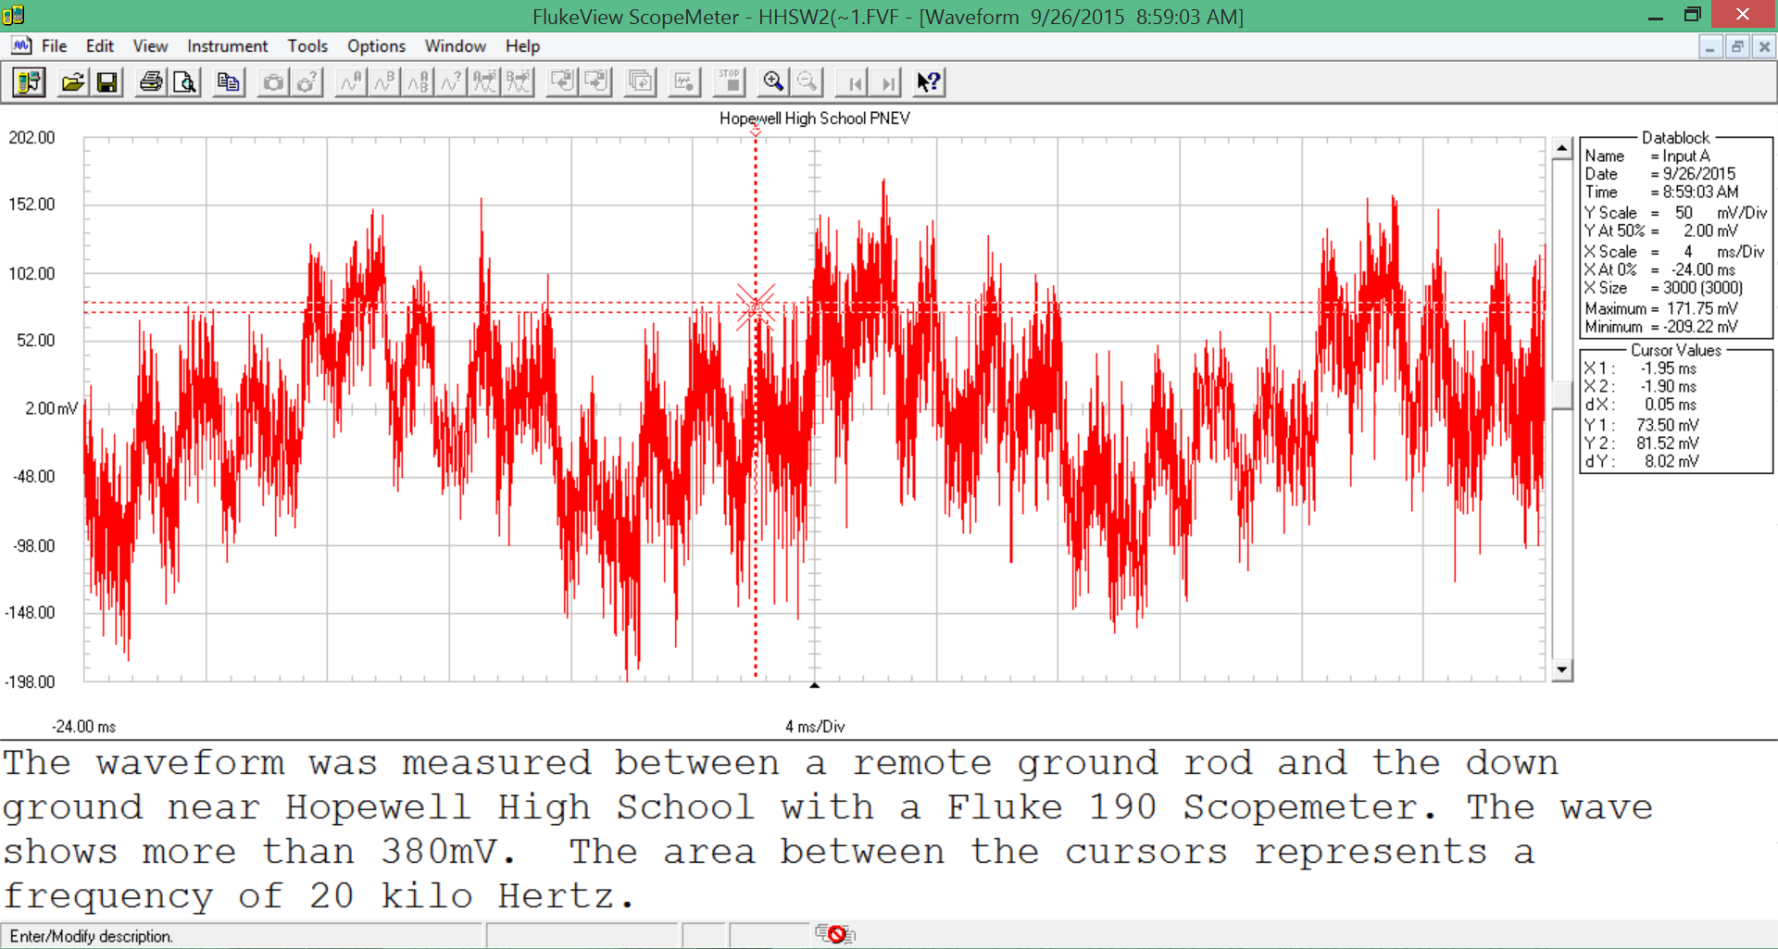
Figure 2
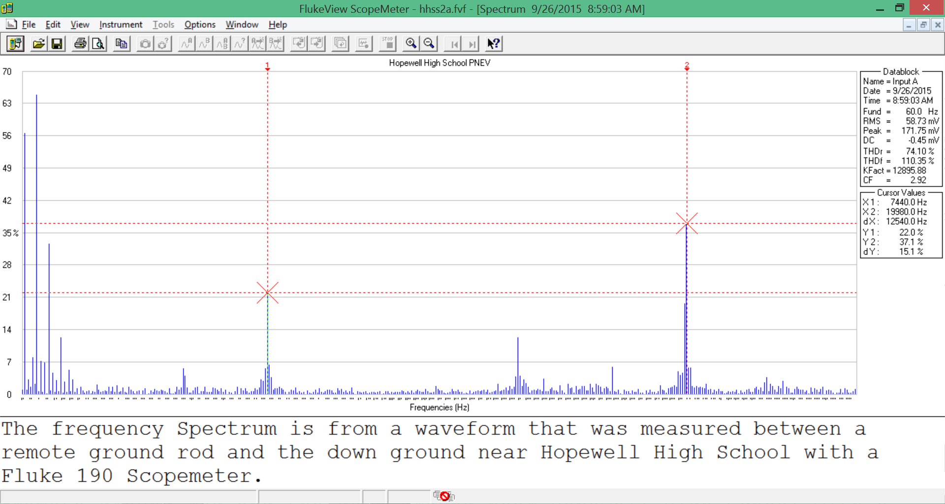

Figure 3
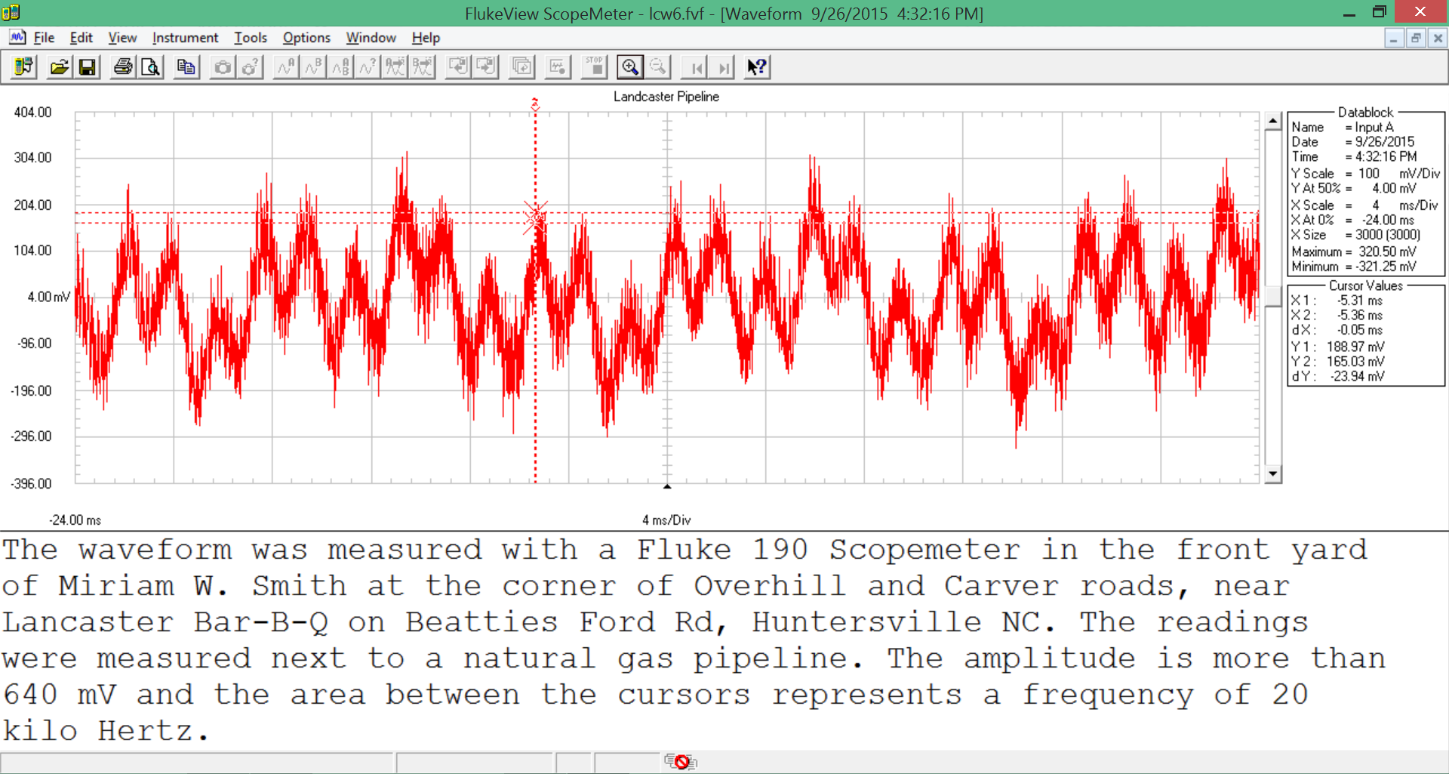

Figure 4
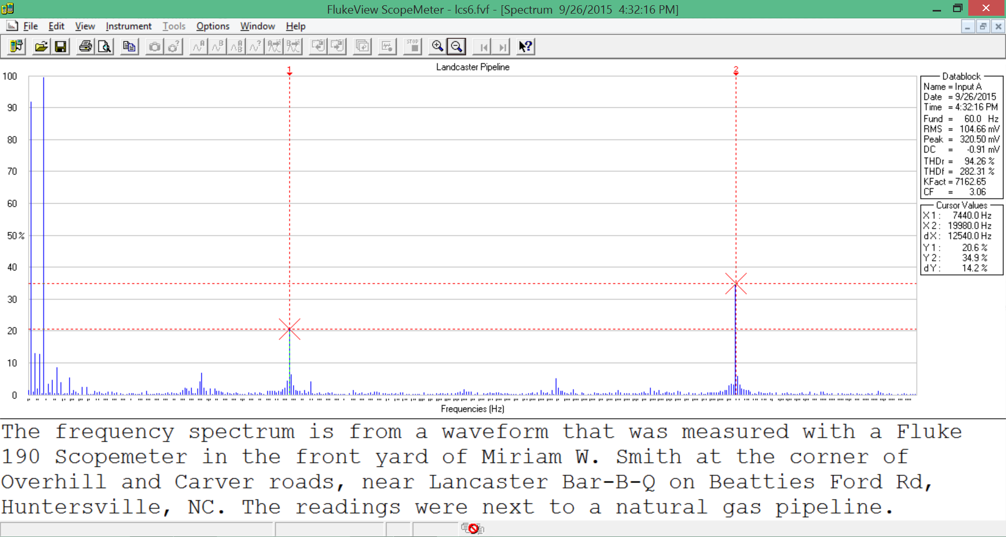

Results and interpretation:
There was a lot of AM radio static in the areas we studied, indicating high frequency electromagnetic pollution in the air at kilohertz frequencies. This is significant, because another case of OM has been recently reported in a policeman whose territory was the Beatties Ford Rd area.
The wave forms and their spectra in the primary neutral to earth ground at the school and the current in the earth at the pipeline are shown above.
The wave forms at both places are highly distorted utility 60 Hz wave forms with 16.8 ms between peaks Remarkably, the spectra at both places are identical with identical peak frequencies of 19,980 Hz. The spectra are as individual as fingerprints or DNA, proving beyond any doubt that the electrical pollution at the school and in the earth at the pipeline had the same source, most likely the VFDs at the LNG plant. In our experience this level of high frequency electrical pollution in the earth and grid causes a wide spectrum of morbidity and mortality in animals and people exposed to it. At highest risk will be the LNG plant employees, teachers and students at the school, and people who live and work near the pipeline. The ocular melanoma cases are the tip of an iceberg of mortality and morbidity in those who have been exposed. During our visit to Huntersville we learned that the brother of one of the fatal OM school cases who also attended the high school was diagnosed with leukemia.
Recommendations:
1. The VFDs on the motors at the Piedmont LNG plant should have filters designed by the manufacturer installed on them. The manufacturers know about the electrical pollution generated by their VFDs and usually have the filters already attached to VFDs marketed in Europe which has stricter electrical pollution rules.
2. The electric utility (ElectriCities) should add an oversized neutral between the LNG plant and the utility substation. Other filters may have to be installed at the plant to comply with the Institute of Electrical and Electronic Engineers IEEE-519 standards. The IEEE 519 limits total harmonic distortion to 5% for voltage and 20 % for current. Europe has strict rules on electrical pollution which are mostly ignored in the US.
3. The Hopewell High School Should be examined electrically and made to comply with IEEE-519 standards.
4. As a public health specialist, I would recommend morbidity and mortality surveillance of current and former Hopewell High school staff and students, with a special focus on ocular melanoma early detection.
Respectfully submitted,
Samuel Milham MD, MPH Dave Stetzer

